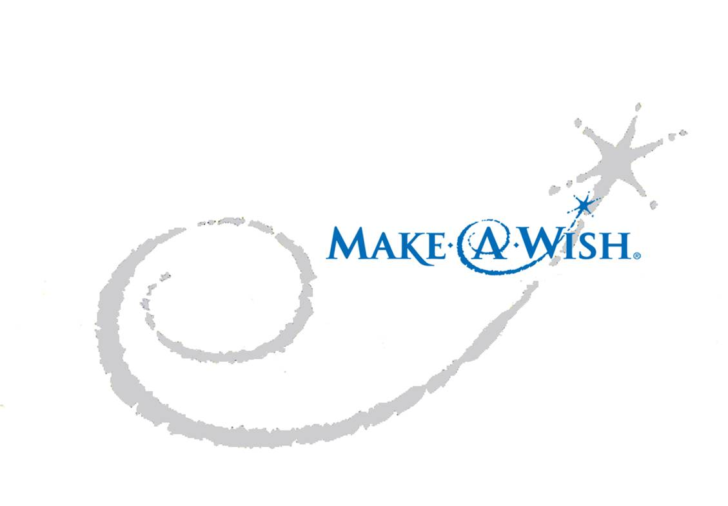 Chi Omega’s Third Annual

Walking for a Wish

To benefit the Make-A-Wish Foundation®

Mail this Form and Checks to:

Chi Omega-Walking for a Wish

5311 Rockhill Road,

Kansas City, Missouri, 64110

More information available at:

Chiowalkingforawish.weebly.com

Donation Amount: _________________ Sponsorship Amount:__________________

Business/Sponsor Name_______________________________________________________

First Name________________________ Last Name________________________________

Street Address______________________________________________________________

City ____________________________State___________________Zip________________

Phone Number__________________ Email Address_________________________________

FOR OFFICE USE:

Total Amount Paid: $____________________ CASH CHECK#_________________



Phone Number____________________ Email Address___________________________

Date of Confirmation________________ Person of Contact_________________________

Benefit Notes: ________________________________________________________________________

________________________________________________________________________

*Contributions made to the Make-A-Wish Foundation of Illinois, a non-profit 501(C)(3) charity, are tax deductible as provided by law.*

**THANK YOU FOR HELPING TO MAKE WISHES COME TRUE!**